Title of Project

 | First Last Name (Class of 62)  1st March – 31 August 2010 |  | 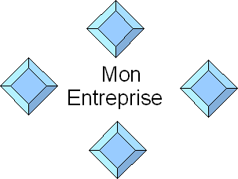
PFE training period /AIE/M2R (doctorate)/other  Monitor ENSEEIHT: First Last Name(Dept) |  | Location: MyCompany, Toulouse (31)  Tutor: First Last Name
Summary: The summary should be limited to approximately 5 lines and should briefly and concisely explain what was done, how, methods used, and main results. Copy all the formats that are used in this template exactly.
Key words: axis of study, fields of application, methods used, programming languages.

Introduction

Structure of the document
To give structure to the document, use sections (format = Title 1 in bold, as for I. Introduction above) and if necessary, sub-sections (format = Title 2 in bold italics as for 1. Structure of the document). These Title formats can be found in Word under Format, then Styles and Formatting. Both are given in size 10 here, while the text is in size 9 using Times New Roman font.

Equations, tables and graphs
Given the limited space available, use only equations, tables, graphs and figures when absolutely necessary. In all cases, equations should be centred as in the example below:
$a+b=c$.
Avoid all punctuation marks in equations except a final period if the equation ends a sentence. All tables, figures, and graphs should be clearly labelled in bold. Labels should be located above tables and below figures and graphs (see Figure 1 and Table 1). In addition, all figures and tables included in the abstract must be cited and briefly explained/referred to.

Figure 1 Telescope

Finally, for graphs, make sure that each axis (X, Y, Z) is appropriately and clearly labelled. For example, in Figure 2, the graph represents a chirp signal profile. The frequency of the signal varies linearly as a function of time and is given by
$$f(t)=f_{0}+\frac{B}{T}t$$
where$f$is the carrier frequency signal, $B$ is the instantaneous bandwidth and $T$is the duration of the signal.

Typography
Please follow appropriate typographical rules. Be careful, they are not the same in French as in English. For example, in French, certain punctuation marks ( ; : ? ! ) are preceded and followed by a space, which is not the case in English.
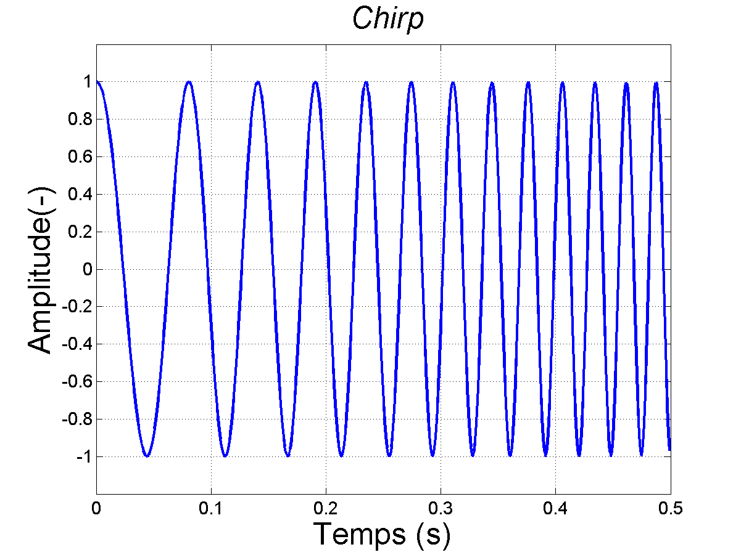
Figure 2 chirp signal profile

Méthods Used
Throughout the document, use Times New Roman font.
Table 1 below lists the size fonts to be used in each section.
In addition, please justify all text, using a two column format.

Table 1 Size of fonts to be used
Section | Size
Title | 20
Author | 12
Bibliographic references et tables | 8
Section & sub-section titles | 10
Other text | 9

Résults
At the end of your abstract, please provide a minimum of bibliographic references which are referred to in the text.
Your abstract must not be more than one page (front in French, back in English). The default parameters for page layout should be respected.

References
- G. Eason, B. Noble, and I. N. Sneddon, “On certain integrals of Lipschitz-Hankel type involving products of Bessel functions,” Phil. Trans. Roy. Soc. London, vol. A247, pp. 529–551, April 1955.
- Y. Yorozu, M. Hirano, K. Oka, and Y. Tagawa, “Electron spectroscopy studies on magneto-optical media and plastic substrate interface,” IEEE Trans. J. Magn. Japan, vol. 2, pp. 740–741, August.

